Meta Description:
Learn what is title tags, why they matter for SEO, best practices to craft compelling ones, and optimization tips to boost rankings with Three Angle Marketing.
https://drive.google.com/drive/folders/1Lr4DlPnFAY9VcqPYyKEu-rRX3fC7vDL-
Interlinking:
https://threeanglemarketing.com/what-is-seo-an-intro-to-search-engine-optimization/
Title Tags

Comprehensive Guide to Title Tags: Importance, Best Practices, and SEO Optimization
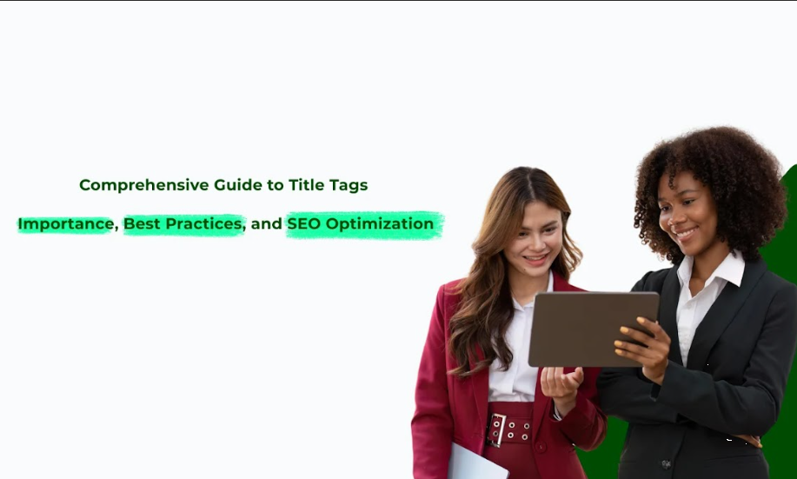
In the ocean of the Internet, all web page elements are important to promote the effectiveness of the digital marketing strategy. Among those elements, title tags are the most critical.
As the main part of the webpage header, title tags make up the essence of efficiently attracting the user’s attention and providing specified data to the search engine. In this guide, we will provide more in-depth information about title tags and make it clear why they are meaningful and how you can apply them for the improvement of the SEO position of your website and for creating more comfortable navigation for the users.

1. What Is a Title Tag?
The title tag is an HTML meta tag placed within the `<head>` section of a webpage. This designates the title of a webpage that displays in the browser window and serves as a clickable headline on the SERP. This header is not only helpful for understanding what information the page contains, but it also has a very important function of increasing the site’s SEO ranking and engaging the user attentively.

Importance of Optimizing Title Tags:
Title tags are very critical from the SEO perspective and are even fundamental in improving user experience. You might not know this fact but it is extremely important and essential for you to know that when it comes to click-through rates (CTR), search rankings as well as browsing experience, creating title tags are very strategic.

How do Title Tags Function as Clickable Headlines in SERPs?
Title tags are essential for the search results because they inform the users about the content of a specific page at once. When users search on the SERPs, it is the title tag that makes them click and take a closer look. , title optimization has become equally important for improving the CTR.

Difference Between Title Tags and H1 Headings:
Even though both title tags and H1 headings help to announce content, the former does it on a different level. Title tags are meta tags that do not appear on the existing webpage, although they appear on SERPs and browser tabs. While H1 tags on the contrary are incorporated in the body of the text and often label the topic of the web page. Both should be equal in terms of how frequently and how closely they are updated, however, they are used for different processes.

2. Why Are Title Tags Important for SEO?
The title tags are very important elements of SEO as they impact a wide range of aspects and processes of a site and its utility to the users.
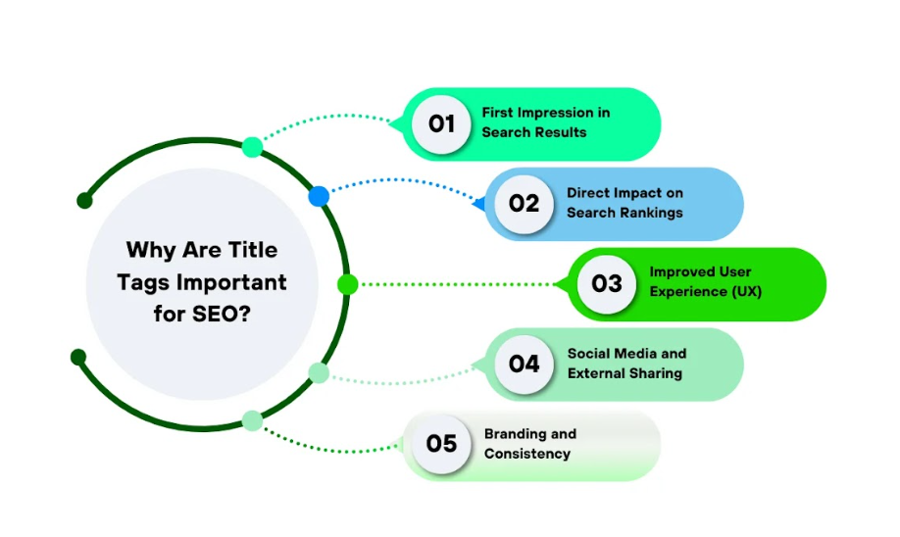

2.1. First Impression in Search Results
Title tags form the first point of contact with the user in result pages They are an important component of any search engine optimization strategy. A well-developed headline can entice the users into clicking through to your site or at the very least provoke their interest. This particular point is crucial, based on it, possible visitors will turn into active users or clients of your page.

The Role of Title Tags on CTR:
It’s a fact that having a good title tag results in a higher click-through rate because it is more noticeable on the SERP page. Strategies aimed at improving CTR include incorporating focused keywords, writing precise and accurate titles, and making sure that the titles reflect the goals and objectives of the users.

The Role of Compelling Titles in Attracting Users:
To create an appeal to the viewers, it is crucial to have engaging headlines. The title tag should be related to the content of the page while at the same time convincing the user to click and find out more on the matter.

2.2. Direct Impact on Search Rankings
Title tags are very useful when it comes to SEO because the search engine uses them in order to identify the topic that is covered on a particular page. Optimized titles will help improve the ranking of the search engine because they provide the search engine with better indexing features.

How Search Engines Use Title Tags to Understand Page Content?
Search engines choose title tags as a key to informing them about a page’s content. Appropriate keywords and good descriptions make up the title tags to facilitate easy categorization of content and its ranking by the search engines.

Correlation Between Optimized Titles and Higher Rankings:
Optimization of title tags for the website is known to have a close relationship with an improved search engine ranking. This way, the title tags can improve visibility in SERPs in a manner that can lead to higher keyword ranking.

2.3. Improved User Experience (UX)
Concise title tags play a vital role in providing a positive user experience by giving direction and information. This increases the likelihood of a user moving through your site’s pages and steps up the bounce rates.

Clear and Descriptive Titles Help Users Navigate Effectively
Descriptive titles make it easier for users to know what is on the website’s home page. This way, title tags enhance the user experience through easy navigation. This makes it easy for the users to locate what they are looking for.

Reduce Bounce Rates with Accurate and Engaging Titles:
If users come to view a certain sort of content and see something else that they don’t want to see, they are most likely to leave and reduce the amount of time spent on the site. Relevant title tags are important for two reasons first, they impact the bounce rate; second, they guide the reader to what to expect in the context with the help of content.

2.4. Social Media and External Sharing
Title tags are also essential for use when the content is shared on social media platforms. They determine how the links look like, concerning people’s chances of interacting with them.

How Title Tags Appear When Shared on Social Platforms?
In the case of a shared link in social media, the title tag is the text used as its heading. The engaging and informative title that is used here increases the likelihood that people will follow the link from these platforms.

Importance of Crafting Shareable and Engaging Titles:
The utilization of better and tasty titles can extend your content and make it smarter and progressively shareable. Those that affect the users more by matching the title to their input are likely to be shared thereby enhancing visibility and traffic.

2.5. Branding and Consistency
Title tags are also a great means for adding branding elements while still keeping all the pages consistent with each other.

Incorporate Brand Names for Recognition:
Title tags help in brand reinforcement by ensuring that they contain your brand name. It convinces the users that the content is related to an appropriate source that is recognized by the users.

Maintain Consistency Across All Pages:
Consistency is important when it comes to title tags on your website because it establishes a brand image and experience among the viewers. It can also be helpful for search indexes to determine the structure and the content of your website because they are usually uniform.

3. Where Do Title Tags Appear?
Another component that plays out in a few noticeable areas concerning your content is the title tags.

Display in Search Engine Results Pages (SERPs)
Meta tags are visible in SERP in the form of the heading for the given webpage or a title tag. Meta tags are used to inform users about the topic of the given page and are some of the first things a user notices when scrolling through the list of results. Choosing the right title tag will decide whether users will click on the link or simply skip over it.

Browser Tabs and Bookmarks:
Besides SERPs, title tags are also displayed in the browser tabs and bookmarks. In the case where people use the ‘save target as’ and click the bookmark option, this event usually displays the title tag by default. This in itself is an indication of why it is necessary to have a coherent title that is brief and with significant content information.

Social Media Previews:
Facebook, LinkedIn, and Twitter also incorporate title tags to generate previews of the shared pieces of content. This means that your Title tag can determine how your contents are shared and viewed on the various Social media platforms and even impact shares, and traffic from these social places.

4. How Long Should a Title Tag Be?
The problem of constructing the proper title tag is about defining how many words should be included and what information should be placed in the title tag. Here’s what you need to know regarding the length of title tags:

Recommended Character Limits:
By the way, it seems the best practice limit for a title tag is approximately 50-60 characters. It guarantees that your title will fit well and is not abbreviated or cut on most if not all SERPs.

Online Resources Describing How Search Engines Cut-off Long Titles:
In most search engine platforms such as Google, titles that contain characters beyond a certain quantity are usually cut off, which creates a situation where the viewer is only exposed to limited information. Truncation can cause the critical keywords to be trimmed and the title tag not to be as appealing to users to facilitate clicks.

Balancing Brevity with Keyword Optimization
You should keep the title short and, at the same time, informative, with a focus on at least some keywords that would reveal the character and the nature of the content. This way, you can increase your website ranking in search engines and help your users to know what they are likely to encounter once they click the links.

5. How to Analyze the Effectiveness of Title Tags?
It is crucial to monitor the performance of the title tags at times to make sure that they are producing the right results. Here are some strategies on how you can easily do so:
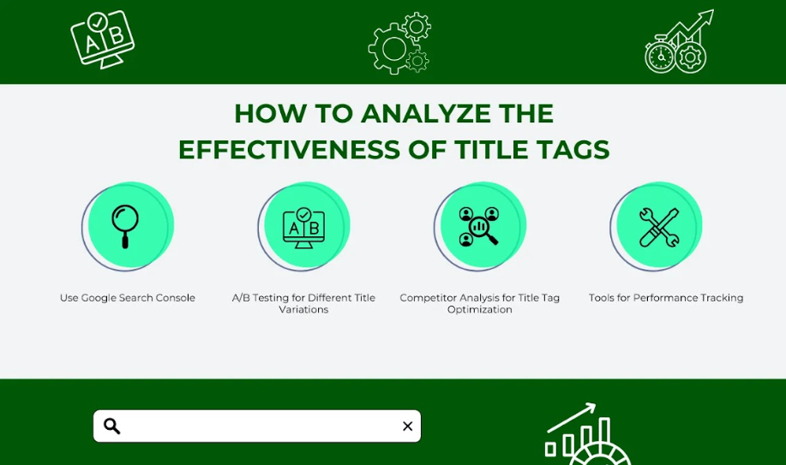

Use Google Search Console:
When it comes to the title tags you want to track their performance in SERPs, Google Search Console is very helpful for this. There are options like impression, click-through rate, and the actual click on a particular page, this way you can determine the title that generates the most traffic. This can help you to get information concerning sub-optimal pages and how to improve them.

A/B Testing Different Title Variations:
A/B testing is a method that helps to find an effective title tag among two or more variants of it and from the point of CTR and conversions. Through variations, you will be in a position to know which of the title tag components contribute positively to the campaign and then adjust accordingly.

Competitor Analysis for Title Tag Optimization:
In this case, reviewing your competitor's title tags is very important as it offers tips and breaks common mistakes. To find out what best practices competitors enjoy, specific software like SEMrush, Ahrefs, Moz, etc. can be used.

Tools for Performance Tracking:
Numerous SEO tools can be used in addition to GSC for managing and analyzing the performance of title tags, including such tools as SEMrush, Ahrefs, Moz, etc. What makes these tools helpful is that they help the user in identifying possible keywords, tracking the ranking of the website, and also learning how title tags make an impact on the SEO.

6. 9 Best Practices to Write a High-Performing SEO Title Tag
In the era of the Internet and the World Wide Web, with an engaging SEO tile tag, your website will be more popular as opposed to your competitors. You should know, in detail, that these selected lines are not only to be visible to the search engine crawlers but also to the first impression of the possible guests. Here are nine things that you should consider when writing successful SEO title tags to improve the CTR.
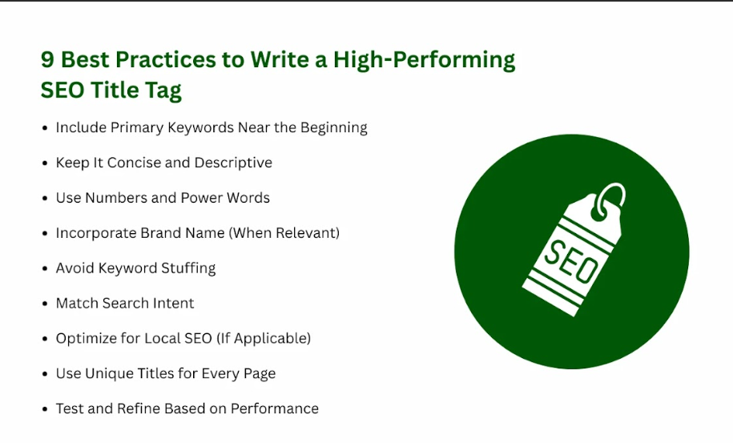

6.1. Include Primary Keywords Near the Beginning
You should place the first keywords that are close to the subject you are searching into the title tag. Together with this, you can allow keywords on the start positions in the title to receive greater prioritization from search engines.
When you target your primary keyword, there are better odds of getting underneath that particular term and enhancing the visibility of your content. Your title also serves as an ‘Elevator Pitch’; the first word contains your focal keyword to draw attention.

6.2. Keep It Concise and Descriptive
The first step is to understand what a title tag is and when it is used and then the focus is on the proper way to write it just as the article suggests. But in this case, the most important thing mentioned is the clarity of the title.
Your title tags should be concise and descriptive when defining the element under discussion. Web crawlers usually do not display more than 60 characters of the title tag, which means anything that may follow may be clipped off and the intended message may be split.
Do not use sensational headlines that have no relation to the article’s material. However, it is recommended to use easily understandable and uncomplicated title tags that give an idea about the content of the page.

6.3. Use Numbers and Power Words
Numbers and power words help in increasing click-through rates (CTR) in every given campaign. Affixes such as “Proven”, “Ultimate”, and “Guide” will make the title sound official, convincing and engaging. It also means that such appeals like “10 Tips” or “5 Steps to” work quite well as they offer readers clear, valuable information they can follow.

6.4. Incorporate Brand Name (When Relevant)
If the brand name has garnered great reputation recognition, adding it to the title tag will enhance its reception. This strategy is effective when you are using your site to create brand awareness and recognition.
For instance, you can use a title like ‘Amazon’s Ultimate Guide to eCommerce Success’ which imply the prestige of the brand gaining the trust of a user and the higher click-through rate.

6.5. Avoid Keyword Stuffing
Keyword stuffing has been a common strategy in the past, but it is one of the definite signs that are likely to harm SEO. It is also important not to have too many relevant keywords in the title, as this is still considered spammy and negatively affects critical functions that people consider when reading text.
Use keywords naturally, and effectively, and make sure that the title is easily understandable by the users.

6.6. Match Search Intent
Some of the tips to achieve good titles include understanding the intent of the user when it comes to searching in particular for the content. As the title is part of the content that’s why should match the intent of the user. Let the title alone depict the kind of results the user should expect to get.
In informing, always use titles that suggest the kind of content that the reader is set to get. This kind of search should also indicate if there is a likelihood of a transaction or an action being made. Each of these two benefits of matching search intent consequently leads to an improvement in customer satisfaction and SEO.

6.7. Optimize for Local SEO (If Applicable)
Small businesses need to ensure that they use location-based keywords to ensure that they appear in the local search engine results. Titles that include city or regional identity targeting the customers can prove useful and give a boost to your targeting of the local search engines. For instance, a title like “Best Digital Marketing Agency in Dubai” will go well with particular, location-based searches, which makes your website easily visible to users from around Dubai.

6.8. Use Unique Titles for Every Page
Having similar titles has adverse effects on the effects of Search Engine Optimization and could take time before any positive changes can begin to show. It is often useful for every page to have a title peculiar to that particular page only and in some cases, the title of the page may contain the keywords. Appropriate and different titles reflect the content of the page to the search engine and make the health of the site better and different from other sites in the searches.

6.9. Test and Refine Based on Performance
SEO isn’t a set-it-and-forget-it task. Periodically monitor the performance of the title tags through analytics. These include CTR, bounce rate as well as the ranking fluctuations. Tweak the titles to find out what works best with audiences and make improvements to them to have maximum response rates.

7. How to Optimize Your Title Tags for Better On-Page SEO
Here’s a breakdown of the processes that should be followed constantly to get the most out of your title tags.

Step-by-Step Guide to Editing Title Tags in CMS:

- Log into your CMS: The first step is to log into your chosen content management system (CMS). A variety of platforms with more or less potential such as WordPress, Shopify, or Joomla offer native settings to modify title tags.
- Locate Title Tag Settings: Now, go to the page or post editing window of the WordPress blog. Usually, there is a field called "SEO,” “Metadata,” or "Preferences,” where you can change the title tag.
- Edit Title Tag: Please input the optimized title in the editable field. It should meet all the guidelines discussed earlier.
- Save Changes: It is always important that you save changes to effect this change in the title tag on your site.

Technical Considerations:
Check that your CMS settings allow for a specific title tag. Otherwise, you should recommend the option of using an SEO plugin or module that offers additional settings and configurations.

Leverage Schema Markup for Enhanced SERP Features:
Employ the use of HTML schema to give the search engine more information regarding the page you want them to rank. This can improve your site's visibility in the SERPs through various features such as rich snippets that may in turn help in increasing the click-through rate.

Mobile Optimization Considerations:
Keep in mind that mobile user traffic makes up a large portion of a website’s traffic in general. Your title tags should be mobile-friendly and share information based on screens obtained from Android tablets or any other similar device.

Conclusion
Title tags are a very important factor that has to be taken into consideration in your search engine optimization methods. For this reason, understanding their relevance, finding out how to write them well, and analyzing their efficiency will help improve your website and attract more visitors. Of course, an appropriate title tag has its importance not only for the possible searchers but also for the users who will be interested in your site. Therefore, it is important to optimize your title tags, intending to improve the traffic visiting your website in an effort to meet your marketing objectives.
At Three Angle Marketing, we pride in offering you professional assistance in tackling all issues to do with SEO and digital marketing. To see more tips and strategies for how you can improve your web presence, keep it locked. Please feel free to contact us in case of any further inquiries. That is why we wrap you with our guidance and assistance so that you may achieve all of your desired goals!

